**Experiment 5 LCD Interface**

**Name:** Kushal Satish Chahjgune

**Roll no:** E42007

**Division:** BE(II)

library IEEE;

use IEEE.STD_LOGIC_1164.ALL;

use IEEE.STD_LOGIC_ARITH.ALL;

use IEEE.STD_LOGIC_UNSIGNED.ALL;

entity lcd is

Port ( clk,reset : in std_logic;

RS,EN,RW : out std_logic;

data : out std_logic_vector(7 downto 0));

end lcd;

architecture Behavioral of lcd is

type state_type is (s0,s1,s2,s3,s4,s5,s6,s7,s8,s9,s10,s11,

s12,s13,s14,s15,s16,s17,s18,s19,s20,s21,s22,s23);

signal state:state_type;

SIGNAL count:std_logic_vector(22 downto 0);

SIGNAL clk1:std_logic;

begin

process(Clk,Reset)

begin

if(Clk' event AND Clk='1')then

count<=count+"0001";

end if;

clk1<=count(20);

end process;

RW<='0';

process(clk1, reset)

begin

if reset = '1' then

state <= s0;

elsif rising_edge(clk1) then

if state = s0 then

state <= s1;

RS<='0'; -- Write commonds to LCD.

EN <= '1';

data <= "00110000"; -- Function set for 8 bit interface, 1 line mode and 5x7 dot matrix.

end if;

if state = s1 then

state <= s2;

EN <= '0';

end if;

if state = s2 then

state <= s3;

EN <= '1';

data <= "00001111"; -- Display cursor and blinking ON.

end if;

if state = s3 then

state <= s4;

EN <= '0';

end if;

if state = s4 then

state <= s5;

EN <= '1';

data <= "00000001"; -- Clear display.

end if;

if state = s5 then

state <= s6;

EN <= '0';

end if;

if state = s6 then

state <= s7;

EN <= '1';

data <= "10000100"; -- Display address.

end if;

if state = s7 then

state <= s8;

EN <= '0';

end if;

if state = s8 then

RS <= '1'; -- Write data to LCD.

state <= s9;

EN <= '1';

data <= "00101010"; --(*)

end if;

if state = s9 then

state <= s10;

EN <= '0';

end if;

if state = s10 then

state <= s11;

EN <= '1';

data <= "01010011"; --S

end if;

if state = s11 then

state <= s12;

EN <= '0';

end if;

if state = s12 then

state <= s13;

EN <= '1';

data <= "01001011"; --K

end if;

if state = s13 then

state <= s14;

EN <= '0';

end if;

if state = s14 then

state <= s15;

EN <= '1';

data <= "01001110"; --N

end if;

if state = s15 then

state <= s16;

EN <= '0';

end if;

if state = s16 then

state <= s17;

EN <= '1';

data <= "01000011"; --C

end if;

if state = s17 then

state <= s18;

EN <= '0';

end if;

if state = s18 then

state <= s19;

EN <= '1';

data <= "01001111"; --O

end if;

if state = s19 then

state <= s20;

EN <= '0';

end if;

if state = s20 then

state <= s21;

EN <= '1';

data <= "01000101"; --E

end if;

if state = s21 then

state <= s22;

EN <= '0';

end if;

if state = s22 then

state <= s23;

EN <= '1';

data <= "00101010"; --(*)

end if;

if state = s23 then

EN <= '0';

end if;

end if;

end process;

end Behavioral;

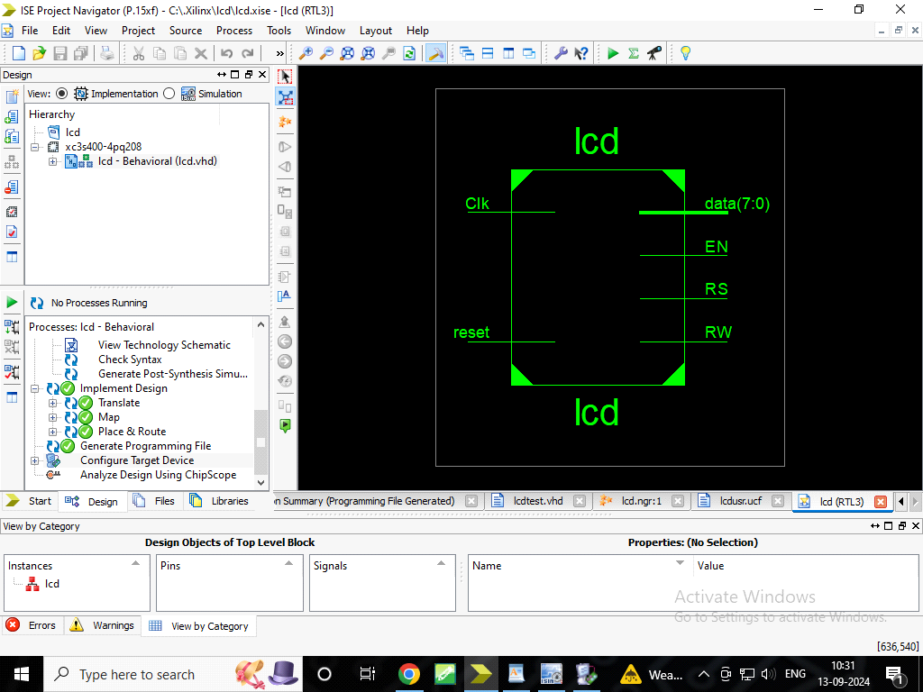

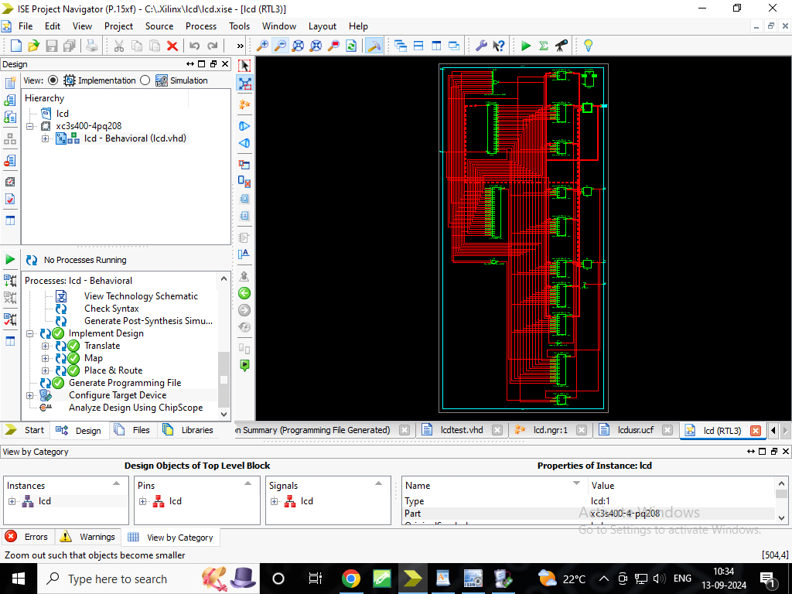

**Testbench:**

LIBRARY ieee;

USE ieee.std_logic_1164.ALL;

-- Uncomment the following library declaration if using

-- arithmetic functions with Signed or Unsigned values

--USE ieee.numeric_std.ALL;

ENTITY lcdtest IS

END lcdtest;

ARCHITECTURE behavior OF lcdtest IS

-- Component Declaration for the Unit Under Test (UUT)

COMPONENT lcd

PORT(

clk1 : IN std_logic;

reset : IN std_logic;

RS : OUT std_logic;

EN : OUT std_logic;

RW : OUT std_logic;

data : OUT std_logic_vector(7 downto 0)

);

END COMPONENT;

--Inputs

signal clk1 : std_logic := '0';

signal reset : std_logic := '0';

--Outputs

signal RS : std_logic;

signal EN : std_logic;

signal RW : std_logic;

signal data : std_logic_vector(7 downto 0);

-- Clock period definitions

constant clk1_period : time := 10 ns;

BEGIN

-- Instantiate the Unit Under Test (UUT)

uut: lcd PORT MAP (

clk1 => clk1,

reset => reset,

RS => RS,

EN => EN,

RW => RW,

data => data

);

-- Clock process definitions

clk1_process :process

begin

clk1 <= '0';

wait for clk1_period/2;

clk1 <= '1';

wait for clk1_period/2;

end process;

-- Stimulus process

stim_proc: process

begin

-- hold reset state for 100 ns.

reset<='0';

wait for clk1_period*10;

-- insert stimulus here

wait;

end process;

END;

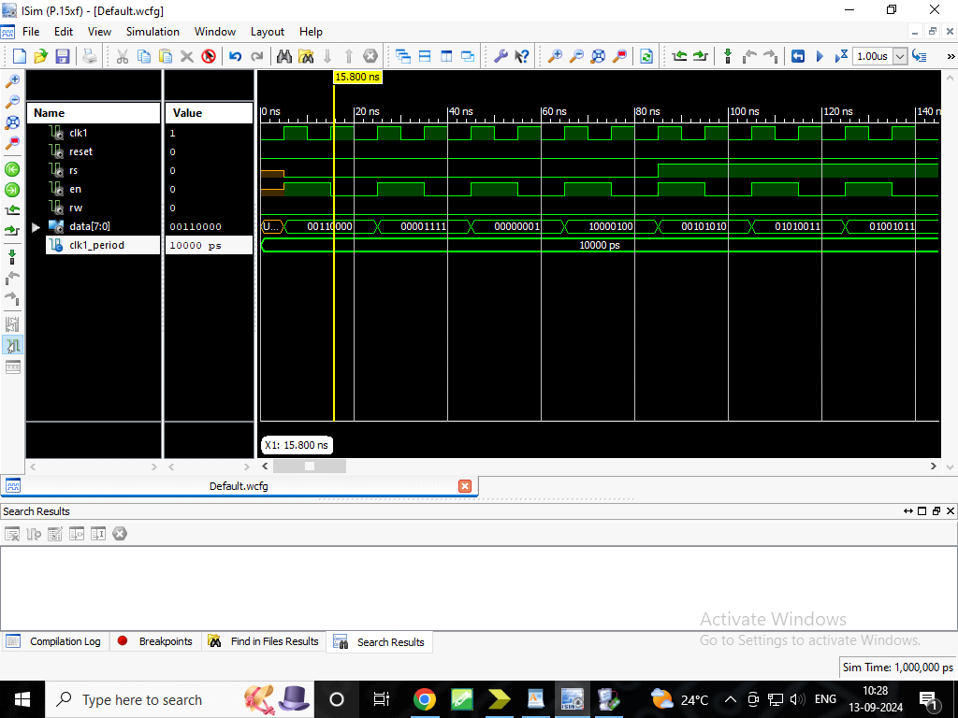

**UCF:**

NET data(0) LOC =P62;

NET data(1) LOC =P63;

NET data(2) LOC =P64;

NET data(3) LOC =P65;

NET data(4) LOC =P67;

NET data(5) LOC =P68;

NET data(6) LOC =P71;

NET data(7) LOC =P72;

NET Clk LOC =P183;

NET reset LOC =P102;

NET RS LOC =P57;

NET EN LOC =P61;

NET RW LOC =P58;

Release 14.1 - xst P.15xf (nt64)

Copyright (c) 1995-2012 Xilinx, Inc. All rights reserved.

--> Parameter TMPDIR set to xst/projnav.tmp

Total REAL time to Xst completion: 0.00 secs

Total CPU time to Xst completion: 0.10 secs

--> Parameter xsthdpdir set to xst

Total REAL time to Xst completion: 0.00 secs

Total CPU time to Xst completion: 0.10 secs

--> Reading design: lcd.prj

TABLE OF CONTENTS

1) Synthesis Options Summary

2) HDL Compilation

3) Design Hierarchy Analysis

4) HDL Analysis

5) HDL Synthesis

5.1) HDL Synthesis Report

6) Advanced HDL Synthesis

6.1) Advanced HDL Synthesis Report

7) Low Level Synthesis

8) Partition Report

9) Final Report

9.1) Device utilization summary

9.2) Partition Resource Summary

9.3) TIMING REPORT

=========================================================================

* Synthesis Options Summary *

=========================================================================

---- Source Parameters

Input File Name : "lcd.prj"

Input Format : mixed

Ignore Synthesis Constraint File : NO

---- Target Parameters

Output File Name : "lcd"

Output Format : NGC

Target Device : xc3s400-4-pq208

---- Source Options

Top Module Name : lcd

Automatic FSM Extraction : YES

FSM Encoding Algorithm : Auto

Safe Implementation : No

FSM Style : LUT

RAM Extraction : Yes

RAM Style : Auto

ROM Extraction : Yes

Mux Style : Auto

Decoder Extraction : YES

Priority Encoder Extraction : Yes

Shift Register Extraction : YES

Logical Shifter Extraction : YES

XOR Collapsing : YES

ROM Style : Auto

Mux Extraction : Yes

Resource Sharing : YES

Asynchronous To Synchronous : NO

Multiplier Style : Auto

Automatic Register Balancing : No

---- Target Options

Add IO Buffers : YES

Global Maximum Fanout : 500

Add Generic Clock Buffer(BUFG) : 8

Register Duplication : YES

Slice Packing : YES

Optimize Instantiated Primitives : NO

Use Clock Enable : Yes

Use Synchronous Set : Yes

Use Synchronous Reset : Yes

Pack IO Registers into IOBs : Auto

Equivalent register Removal : YES

---- General Options

Optimization Goal : Speed

Optimization Effort : 1

Keep Hierarchy : No

Netlist Hierarchy : As_Optimized

RTL Output : Yes

Global Optimization : AllClockNets

Read Cores : YES

Write Timing Constraints : NO

Cross Clock Analysis : NO

Hierarchy Separator : /

Bus Delimiter : <>

Case Specifier : Maintain

Slice Utilization Ratio : 100

BRAM Utilization Ratio : 100

Verilog 2001 : YES

Auto BRAM Packing : NO

Slice Utilization Ratio Delta : 5

=========================================================================

=========================================================================

* HDL Compilation *

=========================================================================

Compiling vhdl file "C:/.Xilinx/lcd/lcd.vhd" in Library work.

Architecture behavioral of Entity lcd is up to date.

=========================================================================

* Design Hierarchy Analysis *

=========================================================================

Analyzing hierarchy for entity <lcd> in library <work> (architecture <behavioral>).

=========================================================================

* HDL Analysis *

=========================================================================

Analyzing Entity <lcd> in library <work> (Architecture <behavioral>).

WARNING:Xst:819 - "C:/.Xilinx/lcd/lcd.vhd" line 36: One or more signals are missing in the process sensitivity list. To enable synthesis of FPGA/CPLD hardware, XST will assume that all necessary signals are present in the sensitivity list. Please note that the result of the synthesis may differ from the initial design specification. The missing signals are:

<count>

Entity <lcd> analyzed. Unit <lcd> generated.

=========================================================================

* HDL Synthesis *

=========================================================================

Performing bidirectional port resolution...

Synthesizing Unit <lcd>.

Related source file is "C:/.Xilinx/lcd/lcd.vhd".

Found finite state machine <FSM_0> for signal <state>.

-----------------------------------------------------------------------

| States | 24 |

| Transitions | 24 |

| Inputs | 0 |

| Outputs | 24 |

| Clock | clk1 (rising_edge) |

| Reset | reset (positive) |

| Reset type | asynchronous |

| Reset State | s0 |

| Power Up State | s0 |

| Encoding | automatic |

| Implementation | LUT |

-----------------------------------------------------------------------

Found 1-bit register for signal <RS>.

Found 1-bit register for signal <EN>.

Found 8-bit register for signal <data>.

Found 23-bit up counter for signal <count>.

Summary:

inferred 1 Finite State Machine(s).

inferred 1 Counter(s).

inferred 10 D-type flip-flop(s).

Unit <lcd> synthesized.

=========================================================================

HDL Synthesis Report

Macro Statistics

# Counters : 1

23-bit up counter : 1

# Registers : 3

1-bit register : 2

8-bit register : 1

=========================================================================

=========================================================================

* Advanced HDL Synthesis *

=========================================================================

Analyzing FSM <FSM_0> for best encoding.

Optimizing FSM <state/FSM> on signal <state[1:24]> with one-hot encoding.

-----------------------------------

State | Encoding

-----------------------------------

s0 | 000000000000000000000001

s1 | 100000000000000000000000

s2 | 010000000000000000000000

s3 | 001000000000000000000000

s4 | 000100000000000000000000

s5 | 000010000000000000000000

s6 | 000001000000000000000000

s7 | 000000100000000000000000

s8 | 000000010000000000000000

s9 | 000000001000000000000000

s10 | 000000000100000000000000

s11 | 000000000010000000000000

s12 | 000000000001000000000000

s13 | 000000000000100000000000

s14 | 000000000000010000000000

s15 | 000000000000001000000000

s16 | 000000000000000100000000

s17 | 000000000000000010000000

s18 | 000000000000000001000000

s19 | 000000000000000000100000

s20 | 000000000000000000010000

s21 | 000000000000000000001000

s22 | 000000000000000000000100

s23 | 000000000000000000000010

-----------------------------------

=========================================================================

Advanced HDL Synthesis Report

Macro Statistics

# FSMs : 1

# Counters : 1

23-bit up counter : 1

# Registers : 10

Flip-Flops : 10

=========================================================================

=========================================================================

* Low Level Synthesis *

=========================================================================

WARNING:Xst:2677 - Node <count_21> of sequential type is unconnected in block <lcd>.

WARNING:Xst:2677 - Node <count_22> of sequential type is unconnected in block <lcd>.

Optimizing unit <lcd> ...

Mapping all equations...

Building and optimizing final netlist ...

Found area constraint ratio of 100 (+ 5) on block lcd, actual ratio is 1.

Final Macro Processing ...

=========================================================================

Final Register Report

Macro Statistics

# Registers : 55

Flip-Flops : 55

=========================================================================

=========================================================================

* Partition Report *

=========================================================================

Partition Implementation Status

-------------------------------

No Partitions were found in this design.

-------------------------------

=========================================================================

* Final Report *

=========================================================================

Final Results

RTL Top Level Output File Name : lcd.ngr

Top Level Output File Name : lcd

Output Format : NGC

Optimization Goal : Speed

Keep Hierarchy : No

Design Statistics

# IOs : 13

Cell Usage :

# BELS : 92

# GND : 1

# INV : 2

# LUT1 : 20

# LUT2 : 1

# LUT2_L : 3

# LUT3 : 3

# LUT3_D : 1

# LUT4 : 14

# LUT4_D : 1

# LUT4_L : 4

# MUXCY : 20

# VCC : 1

# XORCY : 21

# FlipFlops/Latches : 55

# FD : 21

# FDC : 22

# FDCE : 1

# FDE : 10

# FDP : 1

# Clock Buffers : 2

# BUFG : 1

# BUFGP : 1

# IO Buffers : 12

# IBUF : 1

# OBUF : 11

=========================================================================

Device utilization summary:

---------------------------

Selected Device : 3s400pq208-4

Number of Slices: 35 out of 3584 0%

Number of Slice Flip Flops: 55 out of 7168 0%

Number of 4 input LUTs: 49 out of 7168 0%

Number of IOs: 13

Number of bonded IOBs: 13 out of 141 9%

Number of GCLKs: 2 out of 8 25%

---------------------------

Partition Resource Summary:

---------------------------

No Partitions were found in this design.

---------------------------

=========================================================================

TIMING REPORT

NOTE: THESE TIMING NUMBERS ARE ONLY A SYNTHESIS ESTIMATE.

FOR ACCURATE TIMING INFORMATION PLEASE REFER TO THE TRACE REPORT

GENERATED AFTER PLACE-and-ROUTE.

Clock Information:

------------------

-----------------------------------+------------------------+-------+

Clock Signal | Clock buffer(FF name) | Load |

-----------------------------------+------------------------+-------+

count_201 | BUFG | 34 |

Clk | BUFGP | 21 |

-----------------------------------+------------------------+-------+

Asynchronous Control Signals Information:

----------------------------------------

-----------------------------------+------------------------+-------+

Control Signal | Buffer(FF name) | Load |

-----------------------------------+------------------------+-------+

reset | IBUF | 24 |

-----------------------------------+------------------------+-------+

Timing Summary:

---------------

Speed Grade: -4

Minimum period: 6.071ns (Maximum Frequency: 164.717MHz)

Minimum input arrival time before clock: 4.921ns

Maximum output required time after clock: 7.241ns

Maximum combinational path delay: No path found

Timing Detail:

--------------

All values displayed in nanoseconds (ns)

=========================================================================

Timing constraint: Default period analysis for Clock 'count_201'

Clock period: 6.071ns (frequency: 164.717MHz)

Total number of paths / destination ports: 193 / 33

-------------------------------------------------------------------------

Delay: 6.071ns (Levels of Logic = 3)

Source: state_FSM_FFd4 (FF)

Destination: EN (FF)

Source Clock: count_201 rising

Destination Clock: count_201 rising

Data Path: state_FSM_FFd4 to EN

Gate Net

Cell:in->out fanout Delay Delay Logical Name (Net Name)

---------------------------------------- ------------

FDC:C->Q 3 0.720 1.246 state_FSM_FFd4 (state_FSM_FFd4)

LUT4:I0->O 1 0.551 1.140 EN_mux00009 (EN_mux00009)

LUT3_D:I0->O 8 0.551 1.109 data_or000023 (data_or0000)

LUT4:I3->O 1 0.551 0.000 data_mux0000<3>1 (data_mux0000<3>)

FDE:D 0.203 data_4

----------------------------------------

Total 6.071ns (2.576ns logic, 3.495ns route)

(42.4% logic, 57.6% route)

=========================================================================

Timing constraint: Default period analysis for Clock 'Clk'

Clock period: 5.170ns (frequency: 193.424MHz)

Total number of paths / destination ports: 231 / 21

-------------------------------------------------------------------------

Delay: 5.170ns (Levels of Logic = 21)

Source: count_1 (FF)

Destination: count_20 (FF)

Source Clock: Clk rising

Destination Clock: Clk rising

Data Path: count_1 to count_20

Gate Net

Cell:in->out fanout Delay Delay Logical Name (Net Name)

---------------------------------------- ------------

FD:C->Q 1 0.720 1.140 count_1 (count_1)

LUT1:I0->O 1 0.551 0.000 Mcount_count_cy<1>_rt (Mcount_count_cy<1>_rt)

MUXCY:S->O 1 0.500 0.000 Mcount_count_cy<1> (Mcount_count_cy<1>)

MUXCY:CI->O 1 0.064 0.000 Mcount_count_cy<2> (Mcount_count_cy<2>)

MUXCY:CI->O 1 0.064 0.000 Mcount_count_cy<3> (Mcount_count_cy<3>)

MUXCY:CI->O 1 0.064 0.000 Mcount_count_cy<4> (Mcount_count_cy<4>)

MUXCY:CI->O 1 0.064 0.000 Mcount_count_cy<5> (Mcount_count_cy<5>)

MUXCY:CI->O 1 0.064 0.000 Mcount_count_cy<6> (Mcount_count_cy<6>)

MUXCY:CI->O 1 0.064 0.000 Mcount_count_cy<7> (Mcount_count_cy<7>)

MUXCY:CI->O 1 0.064 0.000 Mcount_count_cy<8> (Mcount_count_cy<8>)

MUXCY:CI->O 1 0.064 0.000 Mcount_count_cy<9> (Mcount_count_cy<9>)

MUXCY:CI->O 1 0.064 0.000 Mcount_count_cy<10> (Mcount_count_cy<10>)

MUXCY:CI->O 1 0.064 0.000 Mcount_count_cy<11> (Mcount_count_cy<11>)

MUXCY:CI->O 1 0.064 0.000 Mcount_count_cy<12> (Mcount_count_cy<12>)

MUXCY:CI->O 1 0.064 0.000 Mcount_count_cy<13> (Mcount_count_cy<13>)

MUXCY:CI->O 1 0.064 0.000 Mcount_count_cy<14> (Mcount_count_cy<14>)

MUXCY:CI->O 1 0.064 0.000 Mcount_count_cy<15> (Mcount_count_cy<15>)

MUXCY:CI->O 1 0.064 0.000 Mcount_count_cy<16> (Mcount_count_cy<16>)

MUXCY:CI->O 1 0.064 0.000 Mcount_count_cy<17> (Mcount_count_cy<17>)

MUXCY:CI->O 1 0.064 0.000 Mcount_count_cy<18> (Mcount_count_cy<18>)

MUXCY:CI->O 0 0.064 0.000 Mcount_count_cy<19> (Mcount_count_cy<19>)

XORCY:CI->O 1 0.904 0.000 Mcount_count_xor<20> (Result<20>)

FD:D 0.203 count_20

----------------------------------------

Total 5.170ns (4.030ns logic, 1.140ns route)

(77.9% logic, 22.1% route)

=========================================================================

Timing constraint: Default OFFSET IN BEFORE for Clock 'count_201'

Total number of paths / destination ports: 10 / 10

-------------------------------------------------------------------------

Offset: 4.921ns (Levels of Logic = 2)

Source: reset (PAD)

Destination: EN (FF)

Destination Clock: count_201 rising

Data Path: reset to EN

Gate Net

Cell:in->out fanout Delay Delay Logical Name (Net Name)

---------------------------------------- ------------

IBUF:I->O 25 0.821 1.813 reset_IBUF (reset_IBUF)

INV:I->O 10 0.551 1.134 reset_inv1_INV_0 (reset_inv)

FDE:CE 0.602 EN

----------------------------------------

Total 4.921ns (1.974ns logic, 2.947ns route)

(40.1% logic, 59.9% route)

=========================================================================

Timing constraint: Default OFFSET OUT AFTER for Clock 'count_201'

Total number of paths / destination ports: 10 / 10

-------------------------------------------------------------------------

Offset: 7.241ns (Levels of Logic = 1)

Source: EN (FF)

Destination: EN (PAD)

Source Clock: count_201 rising

Data Path: EN to EN

Gate Net

Cell:in->out fanout Delay Delay Logical Name (Net Name)

---------------------------------------- ------------

FDE:C->Q 2 0.720 0.877 EN (EN_OBUF)

OBUF:I->O 5.644 EN_OBUF (EN)

----------------------------------------

Total 7.241ns (6.364ns logic, 0.877ns route)

(87.9% logic, 12.1% route)

=========================================================================

Total REAL time to Xst completion: 4.00 secs

Total CPU time to Xst completion: 3.89 secs

-->

Total memory usage is 4509380 kilobytes

Number of errors : 0 ( 0 filtered)

Number of warnings : 3 ( 0 filtered)

Number of infos : 0 ( 0 filtered)